Name

Date Pd

**Unit 1 - Worksheet 6:**

**Practice Representing Systems and Change**

For each of the following problems, choose your system so that energy is conserved but do not place anything in the system other than those elements which are essential to include energy conservation.

1. Specify the system, then draw a system schema.
2. Construct Energy Pie Charts for the initial and final states of your system. Add a verbal description of the changes you have represented.
3. Construct Energy Bar Charts for the initial and final states of your system. Be sure to label the “L’s” in your charts and complete the energy-flow diagram
4. 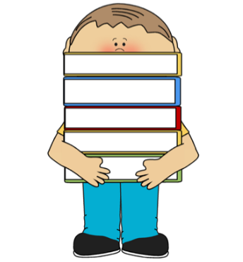A student lifts some books from the bottom of his locker.
   1. System Schema:
   2. Energy Pie Charts:
   3. Energy Bar Chart:

Initial

Energy

0

Final

Energy

0

**System/Flow**

* 1. State Diagrams

1. 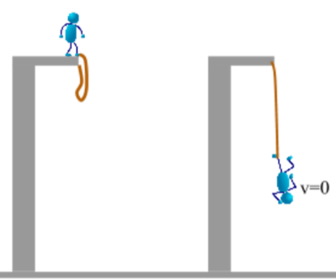A bungee jumper leaps from a bridge, and stretches the cord to it’s maximum length.
   1. System Schema:
   2. Energy Pie Charts:
   3. Energy Bar Chart:

Initial

Energy

0

Final

Energy

0

**System/Flow**

* 1. State Diagrams

1. 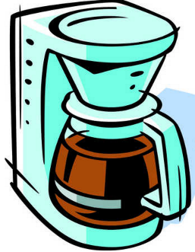A coffee maker is making coffee.
   1. System Schema:
   2. Energy Pie Charts:
   3. Energy Bar Chart:

Initial

Energy

0

Final

Energy

0

**System/Flow**

1. A container of liquid with a thermometer is sitting outside. (fill in for yourself any types of energy storage that you need)

Noon 3 pm 6 pm

* 1. System Schema:
  2. Energy Pie Charts:
  3. Energy Bar Chart:

Initial

Energy

0

Between

Energy

0

**System/Flow**

**System/Flow**

Final

Energy

0